Smart Agricultural Production Optimization Engine (OptiCrop)

Entity Relationship Diagram Documentation:

1. Introduction
The Entity Relationship (ER) Diagram represents the database structure of the Smart Agricultural Production Optimization Engine (OptiCrop). It illustrates the major entities, their attributes, and the relationships between them. The ER diagram provides a logical view of how agricultural data is stored and managed for crop prediction and recommendation.

2. Entities Involved
The system contains seven main entities:
- User
- SoilData
- Crop
- Dataset
- MLModel
- Prediction
- Report

3. Primary Keys
Entity | Primary Key
User | user_id
SoilData | soil_id
Crop | crop_id
Dataset | dataset_id
MLModel | model_id
Prediction | prediction_id
Report | report_id

4. Relationships
- One User can submit multiple SoilData records (1:N).
- One SoilData record generates one Prediction (1:1).
- One Crop can appear in multiple Prediction records (1:N).
- One MLModel generates multiple Prediction records (1:N).
- One Dataset is used to train multiple MLModel records (1:N).
- One Prediction can generate multiple Reports (1:N).

5. Foreign Keys
Entity | Foreign Key
SoilData | user_id
Prediction | soil_id
Prediction | crop_id
Prediction | model_id
MLModel | dataset_id
Report | prediction_id

6. Cardinality
- One user can submit many soil records.
- Each soil record produces one prediction.
- A crop may be recommended in many predictions.
- One ML model can serve many predictions.
- One dataset trains multiple models.
- One prediction can generate one reports containing the summary and recomendations

7. Normalization
The database design follows normalization principles up to Third Normal Form (3NF), reducing redundancy, improving data integrity, and ensuring efficient storage and maintenance.
Information is divided into separate entities:
- User Information
- Soil Data
- Crop Information
- Machine Learning Models
- Dataset Details
- Prediction Results
- Report Generation
This structure improves data consistency and simplifies maintenance.

8. Use Case Coverage
The ER model supports:
- User registration
- Soil data collection
- Crop prediction
- ML model management
- Dataset management
- Report generation
- Agricultural recommendations

9. ER Diagram
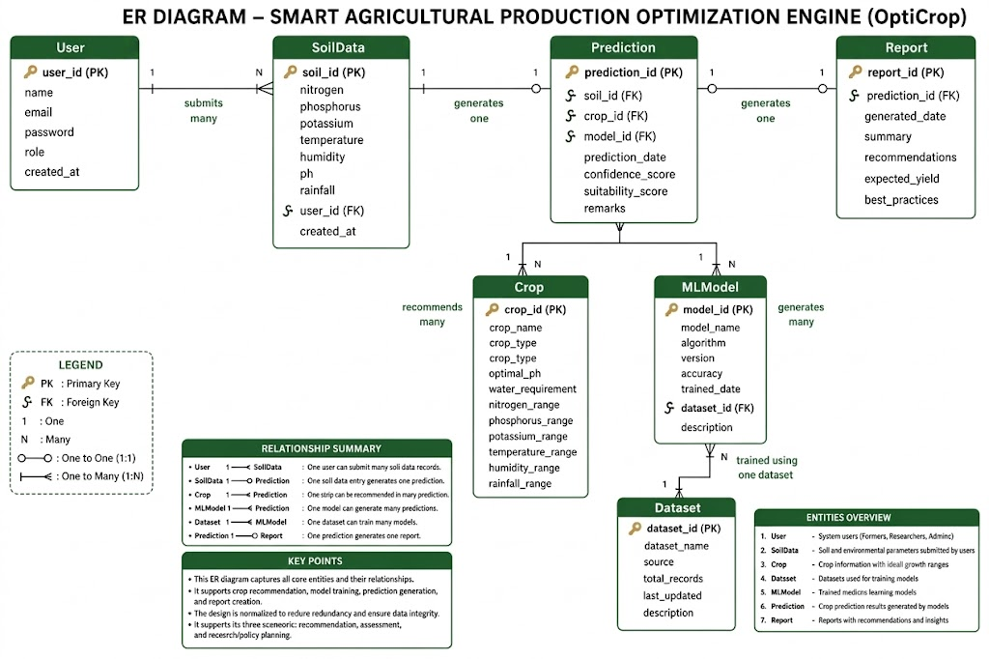

10. Conclusion
The ER diagram provides a scalable and well-structured database design for the OptiCrop system. It supports efficient storage of user, soil, crop, prediction, and report data while maintaining data integrity through well-defined relationships and normalization.

